Project Report

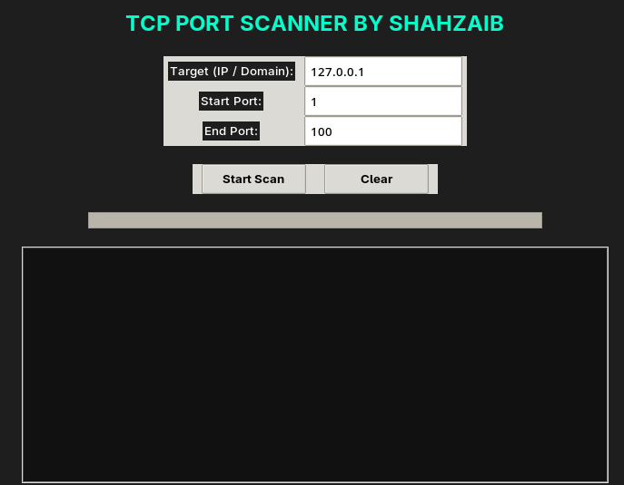

TCP PORT SCANNER

NAME:

SHAHZAIB KHALID

EMAIL:

  - shahzaib43109@gmail.com
Table of Contents
1. Executive Summary 2
2. Introduction 2
3. Project Objectives 2
4. Scope of the Project 3
5. System Requirements 3
5.1 Hardware Requirements 3
5.2 Software Requirements 3
6. Tools and Technologies Used 3
7. System Architecture 3
7.1 Overall Workflow 4
7.2 System Design Explanation 4
8. Functional Requirements 4
9. Non-Functional Requirements 4
10. Technical Implementation 5
10.1 TCP Connection Mechanism 5
10.2 Multi-Threading Implementation 5
10.3 Graphical User Interface Design 5
11. Testing and Validation 6
Test Case 1: Localhost Scan 6
Test Case 2: Manual Open Port Test 6
12. Security and Ethical Considerations 6
13. Advantages of the System 6
14. Limitations of the System 7
15. Future Enhancements 7
16. Conclusion 7
17. References 7

1. Executive Summary
This report presents the development and implementation of a GUI-Based TCP Port Scanner built using Python. The system enables users to scan a specified range of TCP ports on a target host (IP address or domain) and determine whether each port is open or closed.
The application features a modern graphical interface, efficient multi-threaded processing, real-time result display, and structured reporting. The project demonstrates practical implementation of networking concepts and secure coding practices.

2. Introduction
In networking, ports act as communication endpoints for services running on a system. Each service listens on a specific port number. Identifying open ports helps in:
- Network troubleshooting
- Security analysis
- System monitoring
- Vulnerability assessment
This project implements a TCP port scanner that attempts to establish TCP connections to identify open ports within a defined range.

3. Project Objectives
The main objectives of this project are:
- To develop a TCP-based port scanning tool.
- To design a user-friendly graphical interface.
- To implement multi-threading for improved performance.
- To display real-time scanning results.
- To calculate and report open and closed ports accurately.

4. Scope of the Project
The system is designed for:
- Educational and academic purposes
- Cybersecurity laboratory testing
- Localhost and authorized network scanning
The scanner operates within the TCP protocol and supports port ranges from 1 to 65535.

5. System Requirements

5.1 Hardware Requirements
- Standard PC or Laptop
- Minimum 4GB RAM
- Processor: Intel i3 or equivalent

5.2 Software Requirements
- Kali Linux / Linux / Windows
- Python 3.x
- Tkinter library (GUI support)

6. Tools and Technologies Used
Tool / Technology | Purpose
Python | Programming language
Socket Module | TCP communication handling
Threading Module | Parallel port scanning
Tkinter | GUI development
ttk Styling | Modern interface design

7. System Architecture

7.1 Overall Workflow
- User inputs:
  - Target IP or Domain
  - Start Port
  - End Port
- System validates inputs.
- Domain is resolved to IP address.
- For each port in range:
  - A TCP socket is created.
  - A connection attempt is made using connect_ex().
  - The result determines if the port is open or closed.
- Results are displayed in GUI and statistics are calculated.

7.2 System Design Explanation
The system consists of:
- Input Module (User Interface)
- Validation Module
- Scanning Engine (Threaded TCP Scanner)
- Result Display Module
- Statistics Calculation Module

8. Functional Requirements
The system must:
- Accept target IP or domain.
- Accept valid port range (1–65535).
- Perform TCP-based scanning.
- Display open ports in real-time.
- Display total open and closed port counts.
- Show scan completion time.
- Provide progress bar feedback.

9. Non-Functional Requirements
The system should:
- Perform scanning efficiently.
- Maintain responsive GUI during scanning.
- Handle errors gracefully.
- Provide accurate results.
- Be easy to use and understand.

10. Technical Implementation

10.1 TCP Connection Mechanism
The scanner uses the Python socket function:
socket.connect_ex((target, port))
Return values:
- 0 → Port is OPEN
- Non-zero → Port is CLOSED

10.2 Multi-Threading Implementation
Each port is scanned using a separate thread. This allows simultaneous scanning of multiple ports, significantly reducing total scan time.
Threading improves performance compared to sequential scanning.

10.3 Graphical User Interface Design
The GUI includes:
- Target input field
- Start Port input field
- End Port input field
- Start Scan button
- Clear button
- Progress bar
- Result display box
The interface is designed with a dark theme and professional layout.

11. Testing and Validation
The system was tested using:

Test Case 1: Localhost Scan
Target: 127.0.0.1
Result: Successfully detected active system services.

Test Case 2: Manual Open Port Test
Using netcat to open port 4444.
The scanner successfully detected port 4444 as OPEN.

12. Security and Ethical Considerations
Port scanning should only be performed on:
- Authorized systems
- Personal lab environments
- Localhost testing
Unauthorized scanning may violate cybersecurity laws and regulations.

13. Advantages of the System
- Simple and user-friendly
- Fast multi-threaded scanning
- Real-time output display
- Lightweight application
- Suitable for academic learning

14. Limitations of the System
- Supports TCP only (No UDP scanning)
- No service detection
- No banner grabbing
- No OS fingerprinting
- No stealth scanning features

15. Future Enhancements
- Add UDP scanning support
- Implement banner grabbing
- Export results to PDF/CSV
- Add advanced dashboard UI
- Implement thread pool optimization
- Add service version detection

16. Conclusion
The GUI-Based TCP Port Scanner successfully demonstrates the implementation of TCP socket programming, multi-threading, and graphical interface development using Python.
The system meets its objectives by providing accurate, efficient, and user-friendly port scanning functionality. This project reflects practical knowledge in networking fundamentals and cybersecurity concepts.

17. References
- Python Official Documentation
- TCP/IP Networking Fundamentals
- Kali Linux Documentation
- Socket Programming Tutorials

